**Submission Instructions:**

Your submission for this project should be a Word document that includes the following screenshots, each labeled for the step that the screenshot represents:

1. Provide a screenshot to show that you correctly created all of the required folders and that you placed the docker-compose.yml and mosquitto.config files in the Project_24_Docker and config folders, respectively.

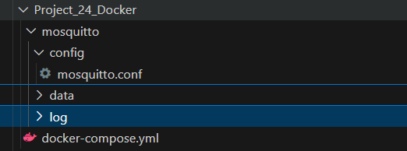

1. Provide a screenshot of your Docker GUI to show that you have successfully initialized the Mosquitto *container*.

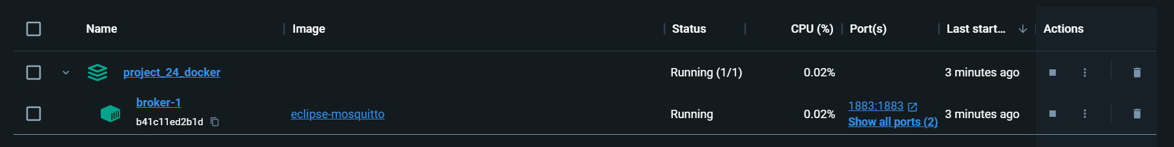

1. Provide a screenshot to show that you have successfully installed the Paho MQTT Python *client* *library*.

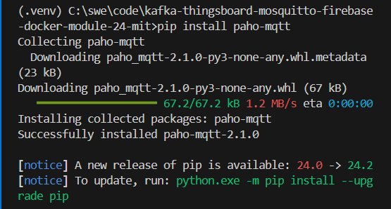

1. Provide a screenshot to show that you created the .mytb-data and .mytb-logs folders inside the home folder correctly.

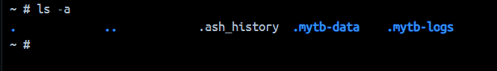

1. Provide a screenshot to show that you correctly created all of the required folders and that you placed the docker-compose.yml inside the ThingsBoard folder.

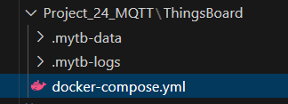

1. Provide a screenshot of your Docker GUI to show that you have successfully initialized the ThingsBoard *container*.



1. Provide a screenshot to show that you created the paho-mqtt folder and modified the code inside the TBPublish.py file to add the humidity *key* with the correct values assigned to the humidity variable.

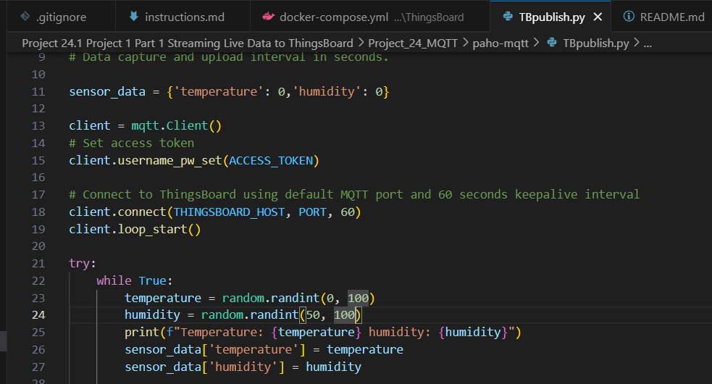

1. Provide a screenshot to show that your code is correctly producing data for the temperature and the humidity.

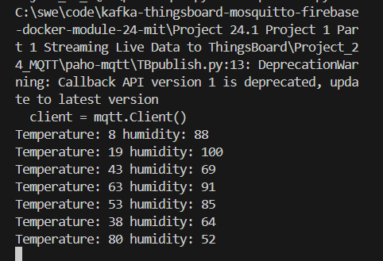

1. Provide a screenshot to show that you successfully logged in to ThingsBoard by using the credentials provided.

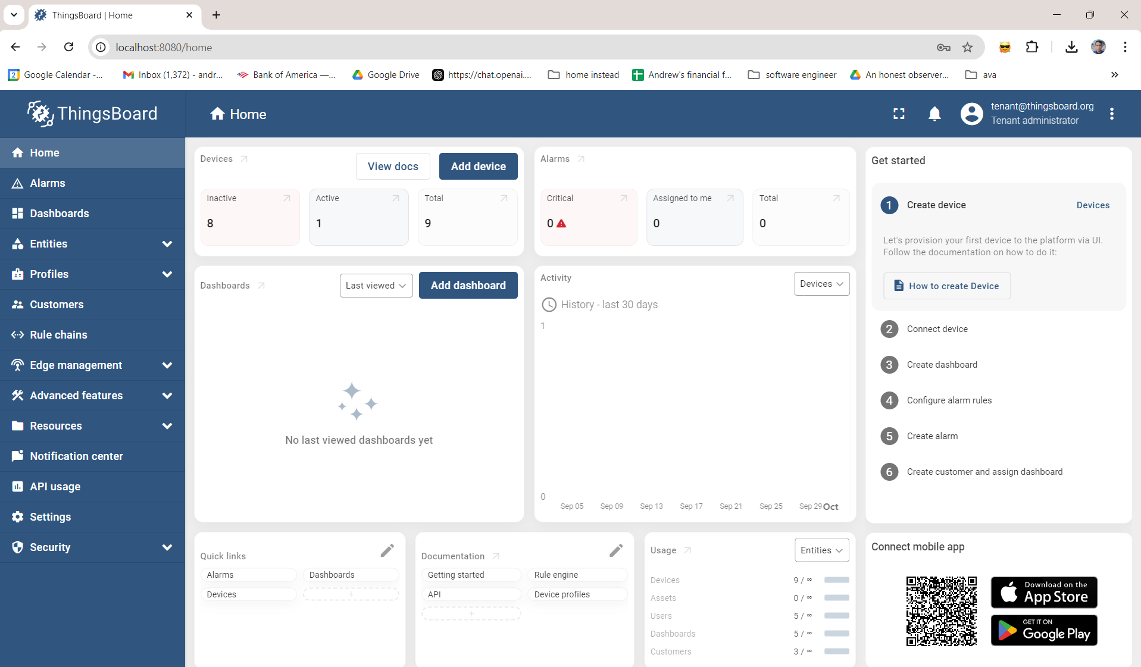

1. Provide a screenshot of the data in the latest telemetry tab to show that the DHT11 Demo *Device* is *publishing* the data produced by the TBPublish.py file to ThingsBoard.

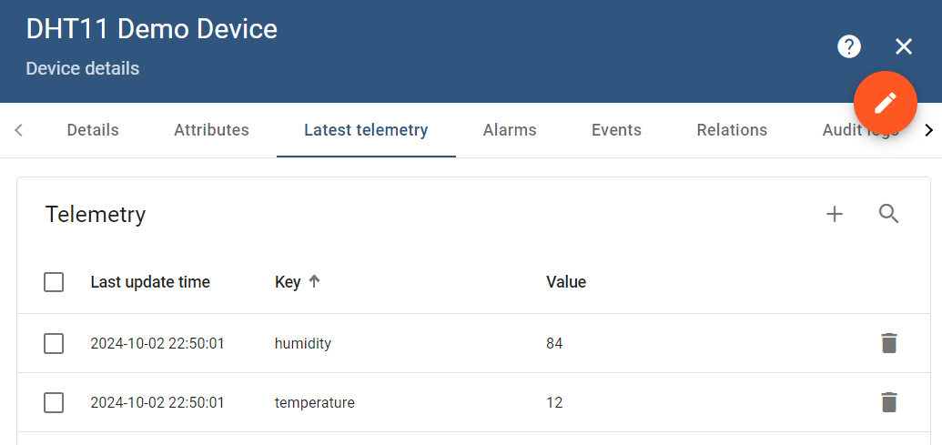

1. Provide a screenshot to show that you created the module24Project project in Firebase.

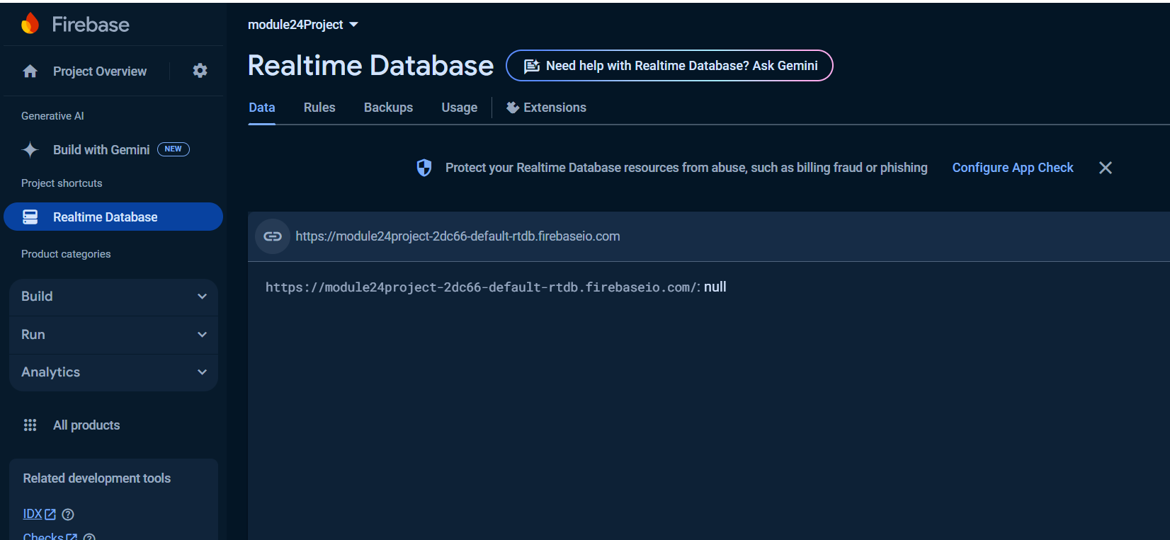

1. Provide a screenshot to show that you created the temperature field inside your Realtime database.

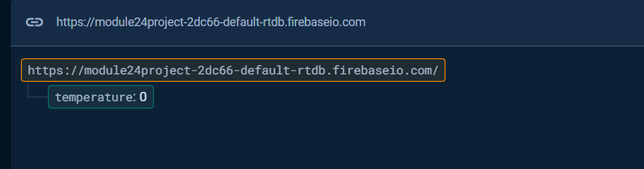

1. Provide a screenshot to show that you have created the Firebase *node* correctly, connected it to the “Message Type *Switch*” *node*, and added “Post telemetry” as the link label.

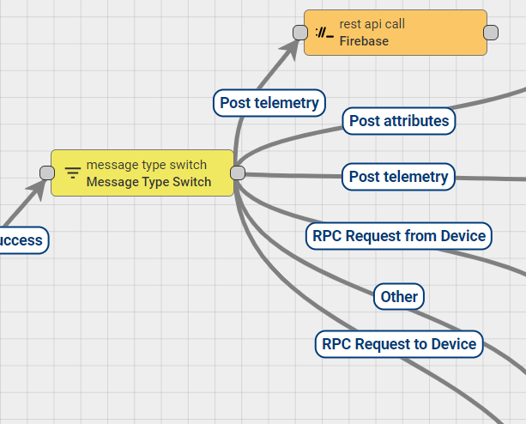

1. Provide a screenshot to show that your Realtime database is updating correctly and displaying your temperature and humidity data.

